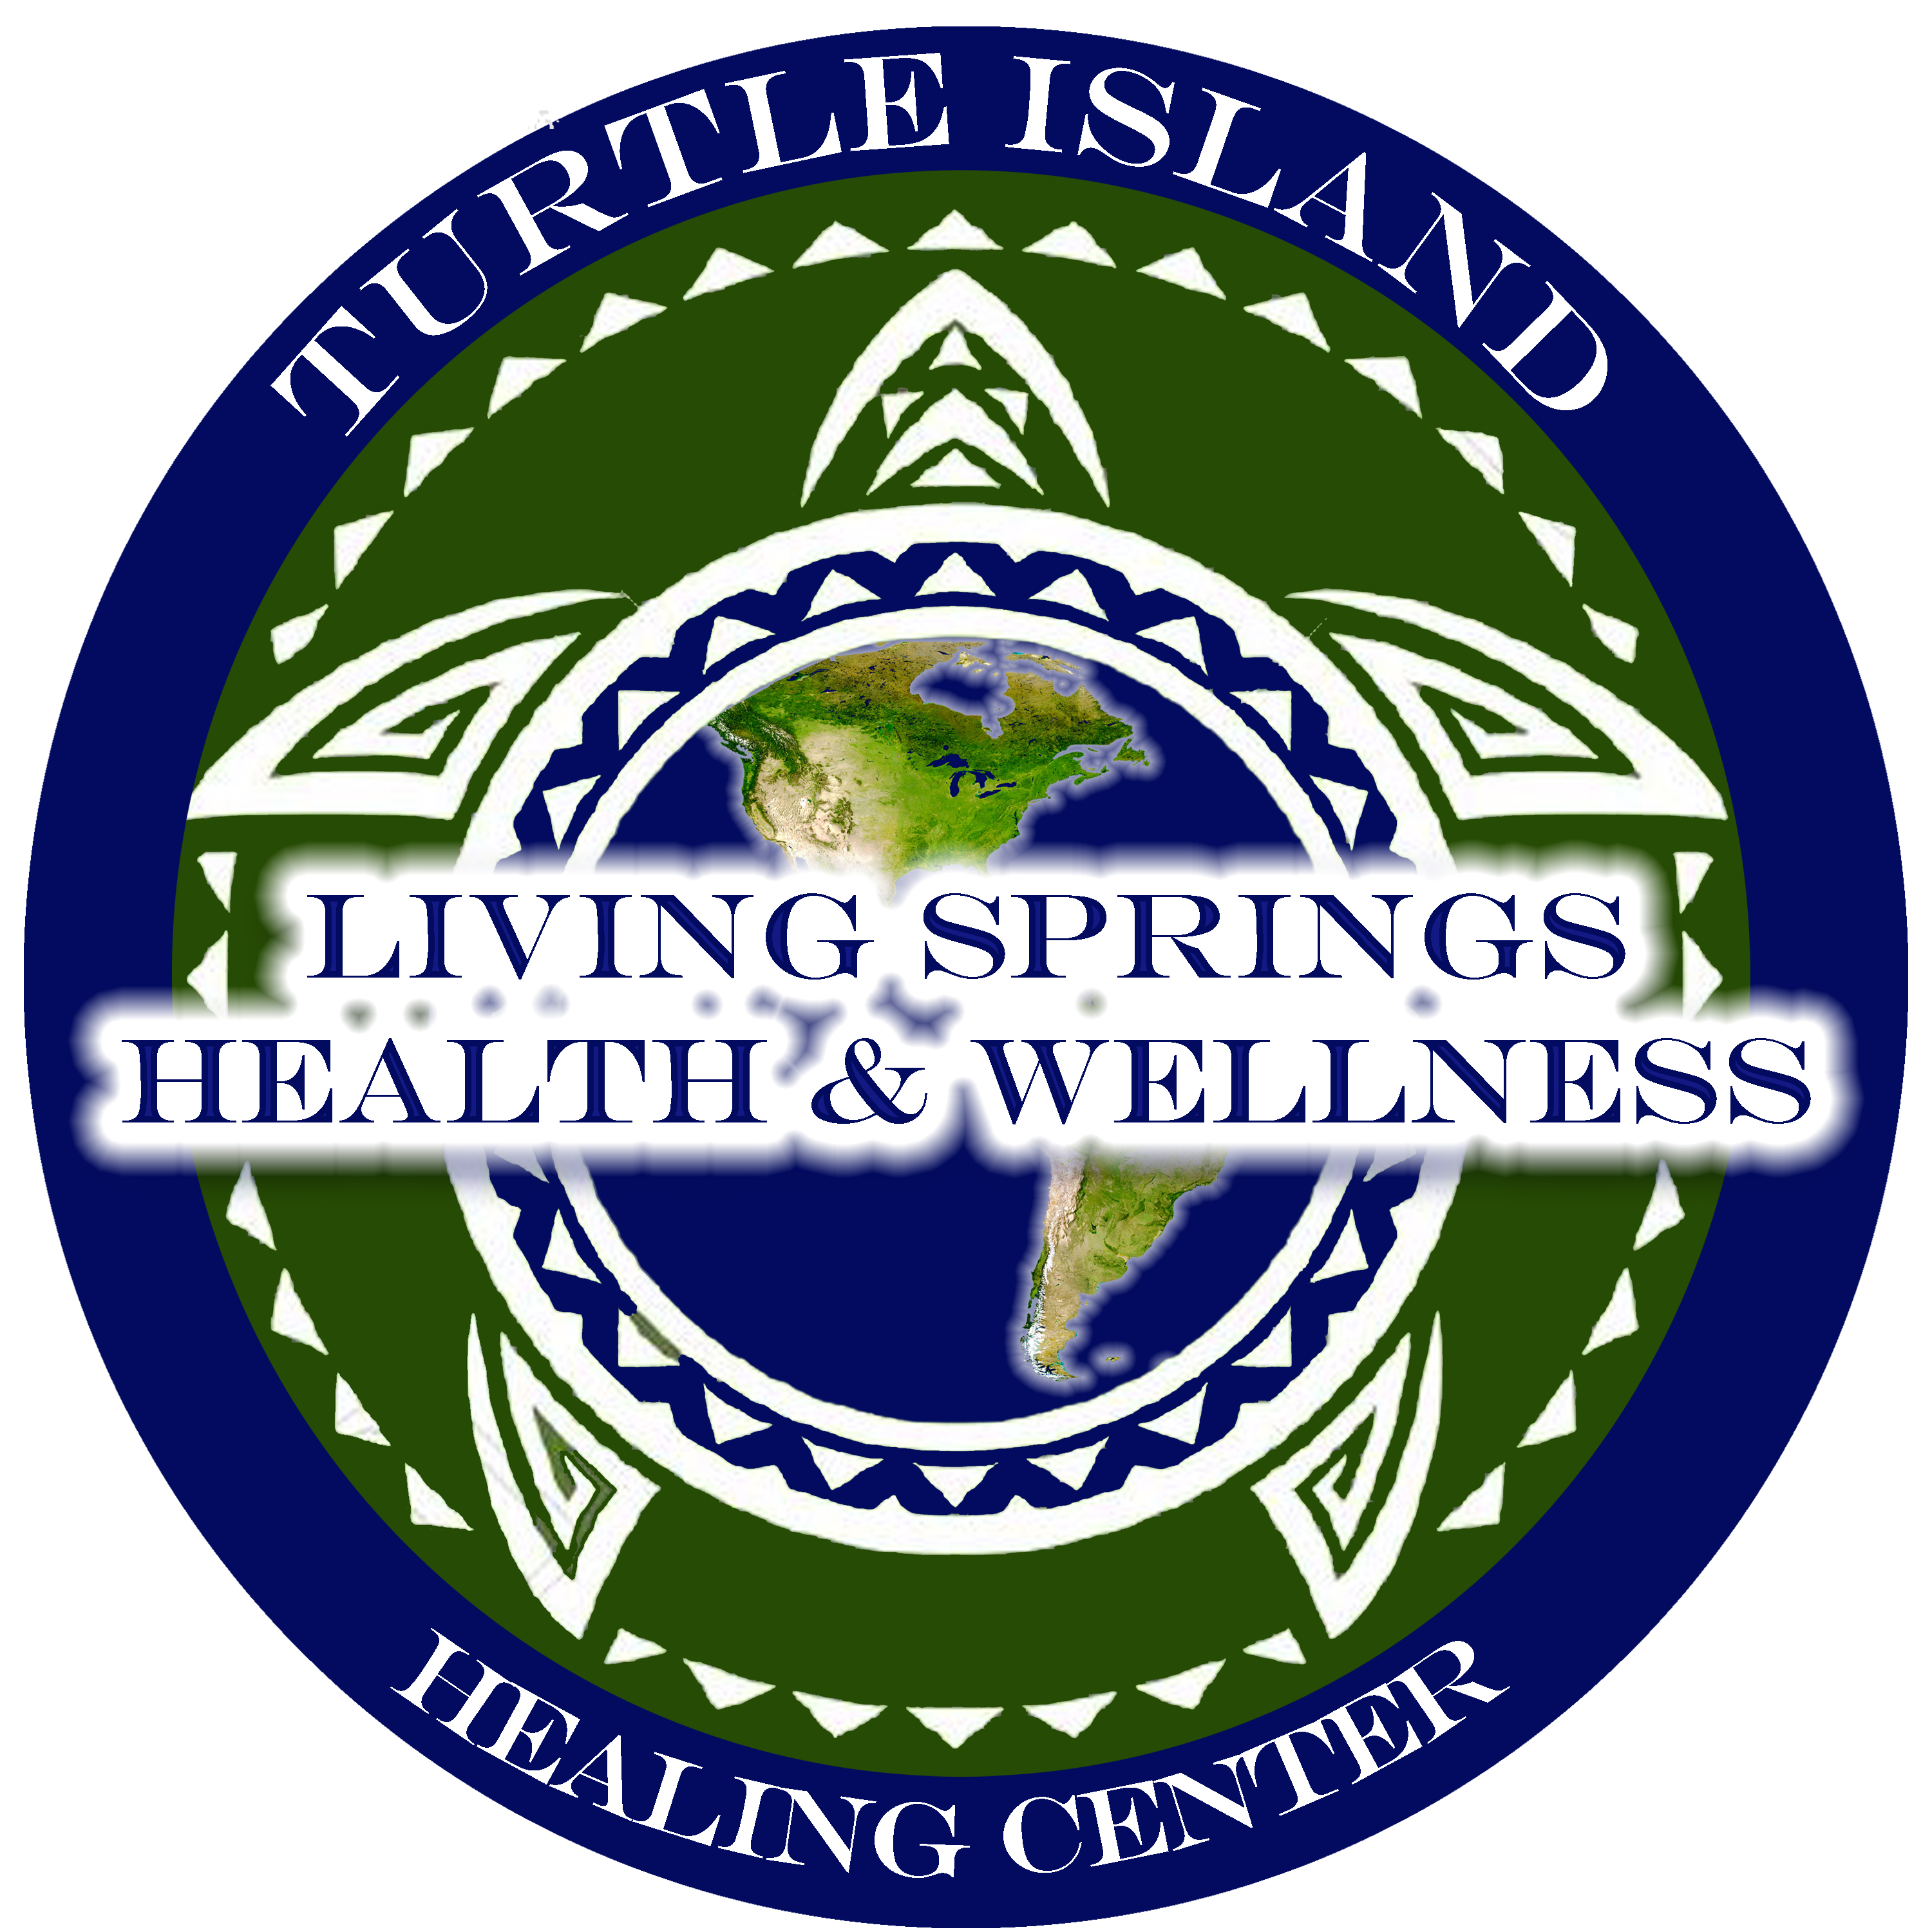 

**Turtle Island Membership Agreement**

**The Turtle Island Provider Network is authorized to train, educate, and license Doctors of Indigenous Medicine, and Certified Practitioners and Healers from American University of Indigenous Medicine, a privately accredited school credentialing under the following categories: Indigenous, Monastic, or Ecclesiastic, Holistic, or Educational and Dynastic. Any jurisdictional claims of any city, county, state or federal agencies or medical board etc. et al- are outside their jurisdiction and the Providers are “excepted”. The business license authorizes jurisdiction for the provider to practice among the membership at large in all 50 states. The Providers and Turtle Healing Priories are a private, “members only” association and not open to the public.**

I/WE,

TYPE NAMES OF MEMBER (AND SPOUSE IF APPLICABLE)

(***PRINT NAMES- MEMBER AND SPOUSE IF APPLICABLE*)**

do hereby request membership under

_________________________________________________________________________________

(***Living Springs Health & Wellness***)

With the signing of this agreement, I/WE, are stating that I/WE have read and agree that I/WE, as people, have a Divinely given right to choose any type of healing that we feel is best for our Mind, Body and Spirit. These options include but are not limited to: ALL forms of natural, Indigenous or earth based healing, Monastic, energy and spiritual healing, whether traditional or nontraditional, conventional or unconventional, as well as allopathic medicine. Turtle Island Healing Priories are not open to the public; and all people seeking services are private members only.

In addition, I/WE affirm and understand that members of the Turtle Island Priory Network, are protected by the First and Fourteenth Amendments to the US Constitution as well as the United Nations General Assembly (10 December 1948, Palais de Chailot, Paris). It is therefore outside the jurisdiction and authority of Federal, State, County, and City Agencies and Authorities concerning any and all complaints or grievances against the Turtle Island Provider Network members and providers. As a member, I/we agree to take any complaint to arbitration through the Turtle Island’s Ecclesiastical Court. All member records are the property of the Turtle Island Grand Priory and are kept completely private.

**[Grab your reader’s attention with a great quote from the document or use this space to emphasize a key point. To place this text box anywhere on the page, just drag it.]**

**I/WE also attest that I am here solely on my behalf and not as an agent or representative for any Federal, State, County, or City Agencies. Furthermore, I/WE do not represent any Massage Board, Medical Board, Zoning Board, Licensing Board, etc… Neither am I on a mission of entrapment or investigation on behalf of these or any other agencies, either on this or any subsequent visit. Any attempt to take information or matters outside this jurisdiction could result in a fine of up to $5,000.00.** Type Your Initials ***Initials*** Spouse’s Initials ***Spouse’s Initials- If applicable.***

**Memorandum of Understanding**

I/WE agree to hold the Director(s), Ministers, Healers, Practitioners, however they are titled, staff and other members of Turtle Island Provider Network harmless from any and all unintentional liability resulting from such care, except for harm that results from instances from a clear and present danger of substantive evil as determined by Turtle Island Provider Network, as stated and defined by the US Supreme Court.

**CONSTRUCTIVE NOTICE**

**Notice is hereby given to any person who enumerated in this Declaration that they may be in violation of our Civil and Constitutional Rights, Title 42, U.S.C 1983 et seq. Title 18, Sec 242, receives a copy of the Declaration, and who, acting under the color of law, intentionally interferes with the free exercise of the Rights retained by Turtle Island Provider Network members under the Ninth Amendment, as enumerated in this Declaration, that they may be in violation of our Civil and Constitution Rights, Title 42, U.S.C 1983 et seq. Title 18, Sec 241.**

**I enclose the sum of $35.00 as consideration for my affiliation and this membership contract. By these presents do I hereby certify, attest and warrant that I have carefully read the above and foregoing Turtle Island Application for Affiliate membership and I fully understand and agree with same.**

**I set my hand this** Numerical Date **day of** Month.**, 20**Year**.**

**__________________________________________________________________________________________**

***Member’ Signature (Sign after filling out & printing form)***

**__________________________________________________________________________________________**

***Spouse’s Signature*** *(If Applicable. If not, leave blank.)*

**Fees: $35.00** for Individual Member and Family

(Includes children 19-26 yrs old unmarried & living at home)

**(Covers for 1 year, $5 per person afterwards)**

|  |  |  |  |  |
| --- | --- | --- | --- | --- |
| ***THESE FIELDS ARE REQUIRED!***  ***IF EACH APPLICABLE FIELD IS NOT COMPLETE, THE MEMBER WILL NOT BE PROCESSED*** | | | | |
| ***Member’s Name: (PLEASE PRINT)*** Type your Name Here | | | | ***DOB:*** Select date of Birth. |
| ***Street Address:*** Enter Street Address | | ***City*** Enter City | ***State:*** Enter State | ***Zip:*** Enter Zip |
| ***Phone:*** Enter Phone Number | | ***Email:*** Enter Email Address | | |
| ***Height:*** Height | ***Weight:*** Weight | ***Eye Color:*** Eye Color | ***Hair Color:*** Hair Color | ***Gender:  Male /  Female*** |
| ***Spouse’s Name (If applicable- PLEASE PRINT):*** Type your Spouse’s Name Here | | | | ***DOB:*** Select date of Birth. |
| ***Height:*** Height | ***Weight:*** Weight | ***Eye Color:*** Eye Color | ***Hair Color:*** Hair Color | ***Gender:  Male /  Female*** |
| ***1st Child’s Name (If applicable- PLEASE PRINT):*** Type your Child’s Name Here | | | | ***DOB:*** Select date of Birth. |
| ***Height:*** Height | ***Weight:*** Weight | ***Eye Color:*** Eye Color | ***Hair Color:*** Hair Color | ***Gender:  Male /  Female*** |
| ***2nd Child’s Name (If applicable- PLEASE PRINT):*** Type your Child’s Name Here | | | | ***DOB:*** Select date of Birth. |
| ***Height:*** Height | ***Weight:*** Weight | ***Eye Color:*** Eye Color | ***Hair Color:*** Hair Color | ***Gender:  Male /  Female*** |
| ***3rd Child’s Name (If applicable- PLEASE PRINT):*** Type your Child’s Name Here | | | | ***DOB:*** Select date of Birth. |
| ***Height:*** Height | ***Weight:*** Weight | ***Eye Color:*** Eye Color | ***Hair Color:*** Hair Color | ***Gender:  Male /  Female*** |
| ***4th Child’s Name (If applicable):*** Type your Child’s Name Here | | | | ***DOB:*** Select date of Birth. |
| ***Height:*** Height | ***Weight:*** Weight | ***Eye Color:*** Eye Color | ***Hair Color:*** Hair Color | ***Gender:  Male /  Female*** |
| ***5th Child’s Name (If applicable):*** Type your Child’s Name Here | | | | ***DOB:*** Select date of Birth. |
| ***Height:*** Height | ***Weight:*** Weight | ***Eye Color:*** Eye Color | ***Hair Color:*** Hair Color | ***Gender:  Male /  Female*** |

**REQUIRED - FOR *PROVIDERS* *ONLY* TO FILL OUT**

Is a person applying the spouse or child of a current member?  Yes /  No   
If yes, provide Members Name: Type Members Name Here

Please check all that apply (This only applies to those who are signing up with this form):

Individual  Spouse  Child under 18  How many children under 18 years of age? # of Children

Child 19-26 years old (unmarried & living at home)  How many children over 19 years of age? # of Children

***Provider Notes:***

